**WORK BREAKDOWN STRUCTURE**



**Project 4 - E-commerce System for Marginalized Communities**





The purpose of this document is to describe the hierarchical work breakdown structure for the project.

**Team members:**

Ronald Chinku 10c4865

Giovanna Contu 10c1399

Dusan Gnjatic 10g0351

Ntsane Kolisang 97k5191

Tsungai Makoni 10m3716

Abram Rankapole 09r0881

**Supervised by:**

Ed De La Rey

Revision History

|  |  |  |
| --- | --- | --- |
| **Version No & Date.** | **Description** | **Author** |
| Version 0 (6 May 2013) | Draft Document | Ntsane Kolisang |
| Version 2 ( 7 May 2013) | Updating Numbering and Listings | Ntsane Kolisang |
|  |  |  |

**Table of Contents**

1.1. Scope 4

# 

## Scope

* + 1. This work breakdown structure will be core to effective project planning, execution, controlling, status assessment, and reporting.
    2. It will be used to identify all work the will be estimated, scheduled, and budgeted.
    3. It operates from the premise set out by the project scope and will provide structure and code that integrates all project work.
    4. It will be used as a management tool throughout the life cycle of a project to identify, assign, and track its total work scope.

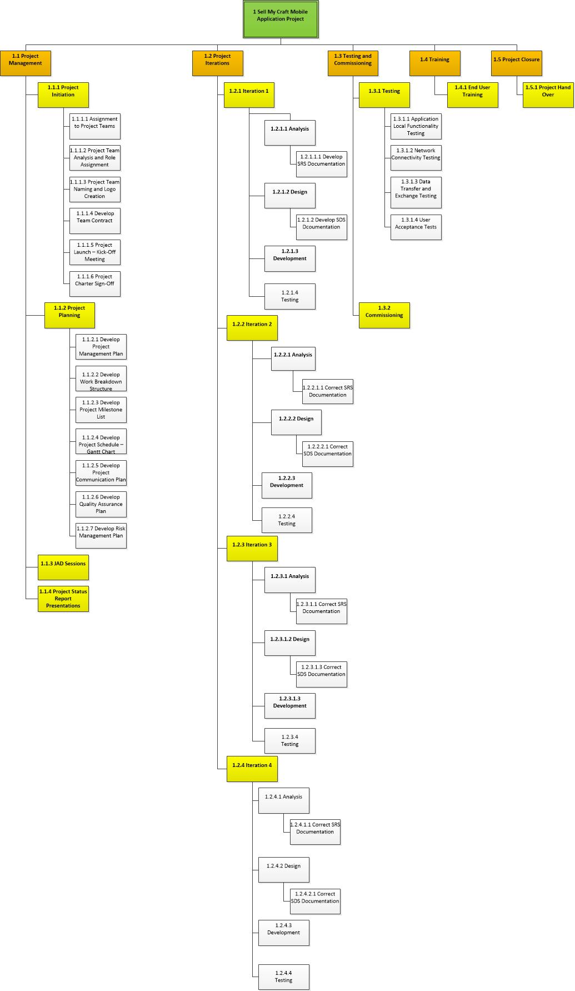

Figure Work Breakdown Structure